No. of 2023 Caribbean Community and Africa Saint Christopher
Export-Import Bank (Agreement and Nevis
for the Establishment of a Partnership)
Bill, 2023

SAINT CHRISTOPHER AND NEVIS

No. of 2023

ARRANGEMENT OF SECTIONS
Section

- Short title
- Interpretation
- Agreement to have the force of law
- Implementation of amendments to the Agreement
- Regulations
SCHEDULE
No. of 2023 Caribbean Community and Africa Saint Christopher
Export-Import Bank (Agreement and Nevis
for the Establishment of a Partnership)
Bill, 2023

SAINT CHRISTOPHER AND NEVIS

No. of 2023

A BILL to provide for giving legal effect to the provisions of the Agreement for the Establishment of a Partnership between Member States of the Caribbean Community and the African Export-Import Bank.

BE IT ENACTED by the King's Most Excellent Majesty, by and with the advice and consent of the National Assembly of Saint Christopher and Nevis, and by the authority of the same as follows:

1. Short title.
This Act may be cited as the Caribbean Community and Africa Export-Import Bank (Agreement for the Establishment of a Partnership) Act, 2023.

2. Interpretation.
In this Act,
“Agreement” means the Agreement for the Establishment of a Partnership between Member States of the Caribbean Community and the African Export- Import Bank;
“Minister” means the Minister responsible for finance.

3. Agreement to have the force of law.
The Agreement has the force of law in Saint Christopher and Nevis.

4. Implementation of amendments of the agreement.
(1) Where an amendment of the Agreement becomes effective, the Minister shall, by Order, amend the Schedule for the purpose of including the amendment.

(2) Where the Schedule is amended, reference in this Act or in any other enactment or in any instrument having effect under any such enactment shall, unless the context otherwise requires, be construed as a reference to the Agreement as so amended.

5. Regulations.
The Minister may make Regulations for giving effect to the provisions of this Act.

SCHEDULE

THE MEMBER STATES OF THE CARIBBEAN COMMUNITY AND THE AFRICAN EXPORT IMPORT BANK (“AFREXIMBANK””)

HAVING REGARD to the Agreement establishing the African Export Import Bank signed in Abidjan, Côte d’Ivoire on the 8th of May 1993, which created the Bank as a multilateral development finance institution with juridical personality;
MINDFUL that Africans on the African continent and Afro-Caribbeans largely share cultural and political ties that run deep based on a shared history and culture, as well as a sense of a common identity and wish to strengthen African solidarity by means of fostering economic cooperation between Africa and the Caribbean;
NOTING THAT in January 2008, by resolution EX.CL/Dec.406(Xlt), the Executive Council of the African Union suggested that the African diaspora be treated as Africa’s sixth region and its participation in the African Union’s organs and activities be strengthened;
FURTHER NOTING THAT by resolution Assembly/AU/Res.1(XVlll) of January 2012, the Assembly of the Heads of States of the African Union have recognized the African diaspora as a substantive entity contributing to the economic and social development of the continent and have invited its representatives as observers to Assembly sessions;
CONSIDERING THAT Afreximbank, an accredited member of the African Union, is fully established, operational and capitalized, and with its subsidiaries, has deepened Africa’s market integration and significantly increased the volume of trade that African countries undertake among themselves and made significant contribution to economic integration and African Continental Free Trade Area (“AfCFTR) implementation;
CONVINCED that the objective of promoting and expanding two-way trade between Africa and the Caribbean, thereby stimulating economic development and promoting South-South cooperation, can best be achieved through the creation of linkages between Africa and the Caribbean;
HAVING REGARD TO Article 5(1) and Article 5(2)(vi) of the Charter which set out the objects and powers of the Bank to facilitate, promote and expand intra-African and extra-African trade and to promote and finance South-South trade between African and Caribbean countries;
PLEDGING that each Participating State shall accord to the Bank a status not less favorable than that of a non-resident corporation, and confirming that the Bank shall enjoy all fiscal exemptions, financial facilities, privileges and concessions granted to international organisations, banking establishments and financial institutions by the Participating States;

HAVE HEREBY AGREED AS FOLLOWS:

ARTICLE I
ESTABLISHMENT, DEFINITIONS

1. There shall be established an international partnership which shall prescribe the guiding framework of engagement between “the African Export- Import Bank (UAFREXIMBANKNŸ, (hereinafter called the Bank”), and the “Member States of the Caribbean Community» which shall operate in accordance with the provisions of this Agreement.
- For the purposes of this Agreement:
  - “Africa” shall mean the continent bounded by the Atlantic Ocean, the Mediterranean Sea, the Red Sea and the Indian Ocean, including the Islands of Cape Verde, Madagascar, Mauritius, Seychelles and Comoros;
  - “Afro-Caribbean” means a person of African descent of Caribbean residence or nationality;
  - “Caribbean” means a region of the Americas that consists of the Caribbean Sea, its islands and the surrounding coasts;
  - “Charter” means the constituent charter appended to the Establishment Agreement which prescribes the provisions for the operation of the Bank;
  - “Establishment Agreement” means the Agreement establishing the African Export Import Bank signed in Abidjan, Côte d’Ivoire on the 8th Of May 1993 and attached as Annex 1 to this Agreement;
  - “Participating States” means those Member States of the Caribbean Community that shall sign this Agreement on or before the date it enters into force, and ratify it and those that shall accede to this Agreement thereafter;
  - “Members of the Caribbean Community” means those States listed in Annex 2 to this Agreement;
- For the avoidance of doubt, this Agreement does not preclude Participating States from becoming Shareholders in the Bank and each Participating State shall encourage, and collaborate with other Member States of the Caribbean Community to facilitate their becoming Shareholders in accordance with the provisions of the Establishment Agreement and the Charter.

ARTICLE II

PURPOSE AND FUNCTIONS
1. To ensure the attainment of the purpose for this Agreement as stated below, Participating States and the Bank agree;
- To cooperate with, support and provide assistance of all types and nature to enable the promotion and financing of South-South trade between African countries and Member States of the Caribbean Community;
- To promote, to the extent permissible under the Establishment Agreement, the financing by the Bank of exports and imports of non-traditional African goods and services and goods and services of Member States of the Caribbean Community in any appropriate form, through extending direct or indirect credit to eligible businesses in Participating States.
2. To collaborate, support and promote the work of the Bank in acting as an intermediary between African exporters and importers and exporters and importers
- of Member States of the Caribbean Community through the issuance of letters of credit, guarantee and other trade documents in support of export-import transactions;
- to support the promotion and provision of insurance and guarantee services covering commercial and non-commercial risks associated with African exports and exports of Member States of the Caribbean Community;
- to provide support to payment arrangements aimed at expanding the international trade of African States and Member States of the Caribbean Community;
- to facilitate the carrying out of market research and the provision of any auxiliary services aimed at expanding the international trade of African countries and Member States of the Caribbean Community and to promote and provide insurance and guarantee services covering commercial and non-commercial risks associated with African exports and exports of Member States of the Caribbean Community;
- to facilitate and support the carrying on of banking operations and the borrowing of funds; and
- to facilitate and support the performance of such acts and do such things as shall be required, desirable, incidental or conducive to the attainment of the foregoing purpose and functions.

ARTICLE III

PARTICIPATION

- Participation in this Partnership Agreement shall be open to all Member States of the Caribbean Community.
- Any Member State of the Caribbean Community which has not signed this Agreement before the date on which this Agreement enters into force shall accede to this Partnership Agreement by depositing an instrument of accession with the Depositary in the form of Annex 3 or any other form acceptable to the Depositary.

ARTICLE IV

REPRESENTATIVE OFFICES AND SUBSIDIARIES

1. The Bank may establish representative offices, agencies or subsidiaries in the territories of Participating States selected by the Board of Directors of the Bank.
2. The Participating State in whose territory a representative office or a subsidiary is to be located shall sign with the Bank, and take all necessary measures to make effective in its territory, an agreement in the form and substance annexed as Annex 4 to this Agreement regarding the location of the respective representative office or subsidiary.

ARTICLE V
IMMUNITIES, EXEMPTIONS, PRIVILEGES, FACILITIES AND CONCESSIONS

Each Participating State shall take all legislative action under its national law and all administrative measures, as are necessary, to enable the Bank to effectively fulfill its purpose and carry out the functions entrusted to it. To this end each Participating State shall accord to the Bank, in its territory, the status, immunities, exemptions, privileges, facilities and concessions set forth in this Agreement, and shall promptly inform the Bank of the specific action it has taken for this purpose.

ARTICLE VI

LEGAL PROCESS

- Actions may be brought against the Bank in any court of competent jurisdiction in the territory of the state in which the Bank has a representative office or a subsidiary, or has carried out any operation or appointed an agent for the purpose of accepting service or notice of process or has otherwise agreed to be sued. No such action against the Bank shalt be brought by: (a) a Participating State; (b) a shareholder or a former shareholder of the Bank or persons acting for or deriving claims from a shareholder or a former shareholder; or (c) any natural or legal persons in respect of: (i) transactions governed by arbitration agreements; (ii) matters pending before an arbitral tribunal; and (iii) personnel matters.

- Without prejudice to the provisions of paragraph 1 of this Article, disputes arising in connection with the operations of the Bank shall be subject to conventional business practices and ordinary legal processes applicable thereto.

ARTICLE VII
IMMUNITY OF PROPERTY AND ASSETS

  - The property and assets of the Bank wherever located and by whomsoever held shall be inviolable and shall be immune from: (a) search, requisition, expropriation, confiscation, nationalization and all other forms of seizure, taking or foreclosure by executive or legislative action; and (b) seizure, attachment or execution before the delivery of final judgment or award against the Bank.

  - Without prejudice to the provisions of paragraph 1 of this Article, the property and assets of the Bank shall be subject to due legal processes and judicial action taken by ordinary courts of competent jurisdiction.
  - For the purpose of this Article and Article Vlll of this Agreement, the term “property and assets of the Bank” shall include property and assets owned or held by the Bank and deposits and funds entrusted to the Bank in the ordinary course of business.

ARTICLE VIII
FREEDOM OF PROPERTY, ASSETS AND OPERATIONS FROM RESTRICTION

- To the extent necessary to implement the purpose of the Bank and carry out its functions, each Participating State shall waive, and refrain from imposing, any administrative, financial or other regulatory restrictions that are likely to hinder in any manner the smooth functioning of the Bank or impair its operations.
- To this end, the Bank, its property, assets, operations and activities shall be free from restrictions, regulations, supervision or controls, moratoria and other legislative, executive, administrative, fiscal and monetary restrictions of any nature.

ARTICLE IX

IMMUNITY OF ARCHIVES

The archives of the Bank and, in general, all documents belonging to, or held by, the Bank shall be inviolable wherever located, except that the immunity provided for in this Article shall not extend to documents required to be produced in the course of judicial or arbitral proceedings to which the Bank is a party or proceedings arising out of transactions concluded by the Bank.

ARTICLE X
PRIVILEGE FOR COMMUNICATIONS

Official communications of the Bank shall be accorded by each Participating State the same treatment and preferential rates that it accords to the official communications of international organizations.

ARTICLE XII
WAIVER OF IMMUNITIES AND PRIVILEGES

The immunities and privileges provided in this Agreement are granted in the interest of the Bank and may only be waived, to such extent and upon such conditions as the Board of Directors of the Bank shall determine, in cases where such a waiver would not, in its opinion, prejudice the interests of the Bank. The President of the Bank shall have the right and the duty to waive the immunity of any officer, employee, consultant or expert of the Bank in cases where, in his opinion, the immunity would impede the course of justice and can be waived without prejudice to the interests of the Bank. In similar circumstances and under the same conditions, the Board of Directors shall have the right and duty to waive the immunity of the President or any Vice-President, Director or Alternate Director of the Bank.

ARTICLE XIII

EXEMPTION FROM TAXATION
- The Bank, its property, assets, income, operations and transactions shall be exempt from ail taxation and custom duties. The Bank, and its receiving, fiscal and paying agents shall be exempt from any obligation relating to the payment, withholding or collection of any tax or duty out of funds owned by, or otherwise appertaining to, the Bank.

- Without prejudice to the generality of the provisions of paragraph 1 of this Article, each Participating State shall take all necessary action to ensure that the property and assets of the Bank, its capital, reserves and dividends, loans, credits, guarantees, securities, and other investments and transactions, interest, commissions, fees, profits, gains, proceeds of realization and other income, return and moneys of any kind, accruing, appertaining or payable to the Bank from any source shall be exempt from all forms of taxes, duties, charges, levies, and imposts of any kind whatsoever, including stamp duty and other documentary taxes, heretofore levied or hereafter imposed in its territory.

- The provisions of paragraphs 1 and 2 of this Article shall be applied without prejudice to the right of the Participating States to tax their residents in the manner each state deems appropriate.

ARTICLE XIV
FISCAL EXEMPTIONS, FINANCIAL FACILITIES,
PRIVILEGES AND CONCESSIONS
- The Bank shall be accorded by each Participating State a status not less favourable than that of a non-resident corporation and shall enjoy all fiscal exemptions, financial facilities, privileges and concessions granted to international organizations, banking establishments and financial institutions by the Participating States.

Without prejudice to the generality of the provisions of Article X and paragraph 1 of this Article by reason of the following enumeration, each Participating State hereby authorizes the Bank to freely and without any restriction, but to the extent necessary to implement its purpose and carry out its functions set forth in this Agreement, to:
  - carry on all forms of banking business and financial services
authorized under this Agreement;
  - purchase, hold and dispose of national currencies;
  - purchase, hold and dispose of convertible currencies, securities, bills of exchange and negotiable instruments, and transfer the same to, from or within the territory of any Participating State;
  - open, maintain and operate accounts in national currencies in the territories of the Participating States;
  - open, maintain and operate convertible currency accounts in the territories and outside the territories of the Participating States;
  - raise funds and make loans in convertible currencies, provided that it shall seek the consent of the Participating State in whose market it intends to raise funds; and
  - carry out any operation authorized under the Charter.

ARTICLE XV

SUPPLEMENTARY AGREEMENTS

Each Participating State may enter into a supplementary agreement with the Bank to the extent necessary to attain the purpose of this Agreement.

ARTICLE XVI
INTERPRETATION AND SETTLEMENT OF DISPUTES

1. This Agreement shall be interpreted in the light of its primary purpose of enabling the Bank to discharge its functions and fulfill its purpose in the furtherance of intra-African, extra-African and South-South trade fully and efficiently.
2. Any dispute among the parties to this Agreement or between the Bank and a party to this Agreement regarding the interpretation or application of any provision of this Agreement or any supplementary agreement shall be resolved preferably through direct negotiations between the parties.
3. In the case of a dispute between the Bank and a Participating State who has ceased to be a Shareholder of the Bank, or whose nationals have ceased to be Shareholders of the Bank, or a dispute between the Bank and a party to this Agreement upon the termination of the operations of the Bank, such dispute shall be referred for final decision to a tribunal consisting of three arbitrators; one arbitrator selected by the Bank, the second arbitrator by the party to the dispute, and the Bank and the party to the dispute shall appoint the third arbitrator. If within a period of sixty (60) days of receipt of notice of arbitration either party has not appointed an arbitrator, or if within thirty (30) days of the appointment of the two arbitrators, the third arbitrator has not been appointed, the said arbitrator shall be appointed by the Secretary-General of the International Center for the Settlement of Investment Disputes, at the request of either party. The procedure of arbitration shall be fixed by the arbitrators, but the third arbitrator shall have full power to settle all questions of procedure where the arbitrators are in disagreement with respect thereto. An award rendered by the majority of the arbitrators shall be final and binding on the Bank and the party to the dispute.

ARTICLE XVII

ENTRY INTO FORCE

- This Agreement shall be open for signature by the Member States of the Caribbean Community listed in Annex 2 and shall be subject to ratification, acceptance, or approval.
- The present Agreement shall enter into force on the day when:
  - two (2) Member States of the Caribbean Community and the Bank have signed the Agreement; and
  - two (2) instruments of ratification, acceptance and/or approval
have been deposited.
- Member States of the Caribbean Community which have not signed this Agreement before its entry into force may, pursuant to paragraph 2 of Article Ill, accede to this Agreement by depositing an instrument of accession with the Depositary.
- This Agreement shall take effect for each Member State of the Caribbean Community on the date of deposit of its instrument of ratification, acceptance, approval or accession in accordance with its constitutional or other applicable statutory procedures and for the bank on signature by its President.

ARTICLE XVIII

DEPOSITARY

Instruments of ratification, acceptance, approval or accession shall be
deposited with the Executive-Secretary of the Bank.

IN WITNESS WHEREOF the undermentioned representatives duly authorised in that behalf have executed this Agreement.


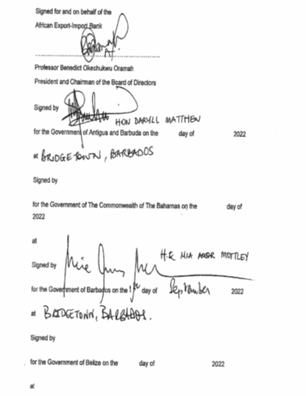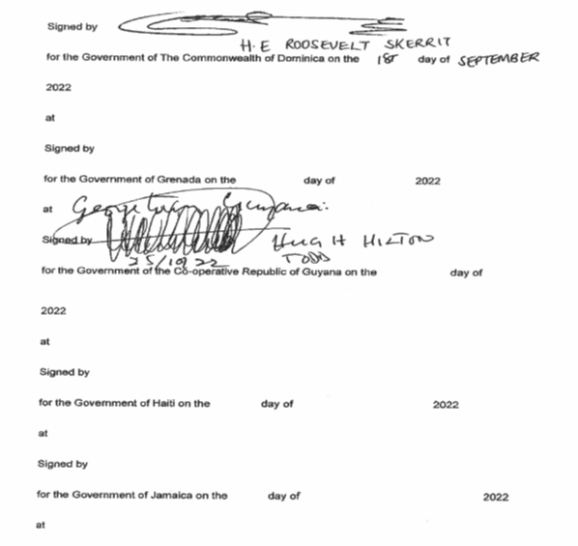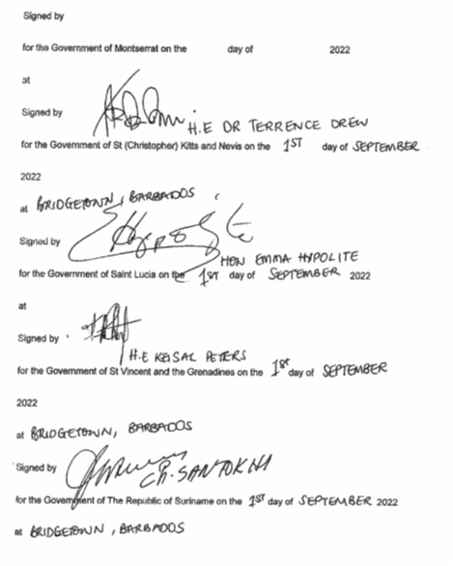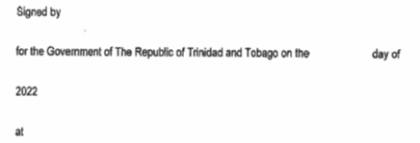

……………………………..
Lanein K. Blanchette
Speaker

Passed by the National Assembly this day of , 2023.

……..………………………………….
Trevlyn Stapleton
Clerk of the National Assembly

